GMI German-Malaysian Institute

DIPLOMA PROGRAMME
Practical Test
Academic Period: July 2024

Code |  | SPG 0542 |  |  | Course Name |  | BASIC OF PROGRAMMING
Title |  |  |  |  | Examiner |  | SITI NABILAH
Name |  | 1. Abdul Hariz bin Mohd Sarnudin (CBS24070208)  2. Aiman Danish bin Mohd Khairunnizam (CBS24070041) |  |  | Program/ Group
Reminder: GMI considers plagiarism and/or copying as a serious breach of academic conduct. Students who are caught doing so will face severe penalty.
No | Assessment Criteria |  | CLO | PO | Level of Diff | Full  Marks |  | Score | Marks | Comment
 | Insert marks based on no of student entered |  |  |  |  | 5
 | Display menu [4 options] |  |  |  |  | 5
 | Display highest mark |  |  |  |  | 10
 | Display lowest mark |  |  |  |  | 10
 | Display average marks |  |  |  |  | 10
6. | Apply array statement |  |  |  |  | 5
7. | Apply function statement |  |  |  |  | 5
Total |  |  |  |  |  | 50
Total Marks
Total |  |  |  | PO
 |  |  |  | PO
Signature

Answer all questions.

- Write a C program to allow users to input marks for multiple students and store them in an array.

- Implement a menu interface at least four options, including an exit option.

- Provide functionality to find the lowest marks among the entered marks.

- Provide functionality to find the highest marks among the entered marks.

- Provide functionality to find the average marks among the entered marks.

- Utilize function statements to implement the functionality for finding the lowest, highest, and average marks.

- Test the program to ensure correct functionality and efficiency.

- You can refer sample output given below:
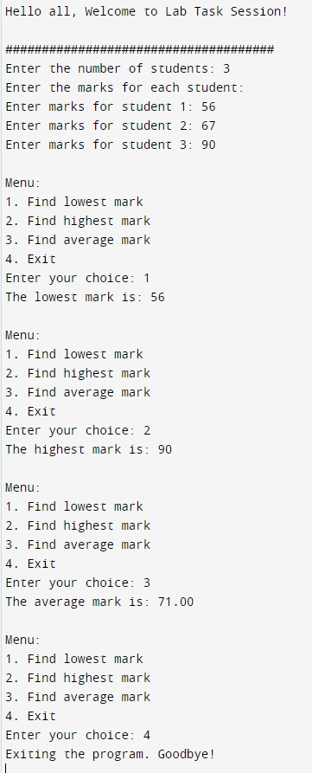

Documentation
- Copy and paste the C program from a compiler into Microsoft Word.

#include <stdio.h>

int s;
int student[100];
int arr;
int opt;
int i;
int stu;
void inputmarks();
void displaymark();
void highestmark();
void lowestmark();
void average();

int main()
{
printf("Practical Test : DCBS 1 ( Hariz & Aiman )\n\n********************************");
inputmarks();
printf("\n");
menu();
}

void inputmarks()
{
printf("\nEnter Number of students: ");
scanf("%d", &s);
printf("Enter the marks for each student:\n");

for(int i = 0;i < s; i++)
{
printf("Enter marks for student %d: ", i + 1);
scanf("%d", &student[i]);
}

}

void menu()
{
do {
printf("\nMenu\n1. Find lowest mark\n2. Find highest mark\n3. Find average mark\n4. Exit\n");
printf("Enter your choice: ");
scanf("%d", &opt);

switch(opt){

case 1:
lowestmark();
break;
case 2:
highestmark();
break;
case 3:
average();
break;

}

}while ( opt != 4);
printf("Exiting the program.. Thank you !");
printf("\n");

}

void highestmark()
{
int max = student[0];
for(i = 0; i < s; i++)
{
if (student[i] > max)
{
max = student[i];
}
}
printf("The highest mark is: %d\n", max);

}

void lowestmark()
{
int min = student[0];
for(i = 0; i < s; i++)
{
if (min > student[i])
{
min = student[i];
}
}
printf("The lowest mark is: %d\n", min);
}

void average()
{
float total = 0;
float avg = 0;
for(i = 0;i < s; i++)
{
total = total + student[i];
avg = total / s;
}
printf("The average mark is: %.2f\n", avg);

}

- Take a screenshot of the displayed output.

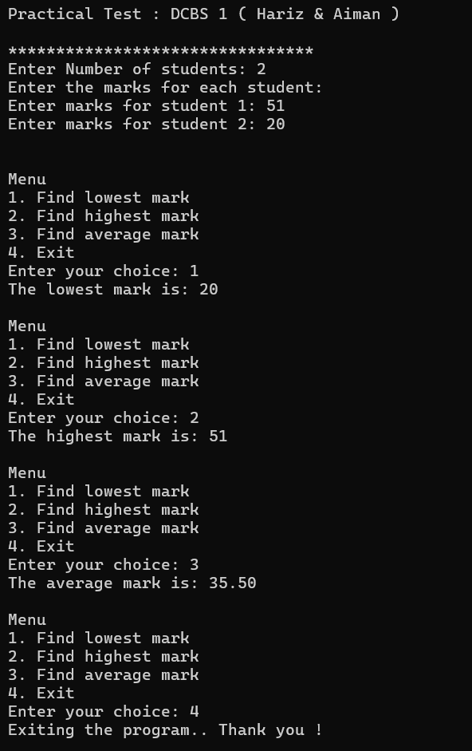

- Upload the C program file.

